Human Nutrition Question Bank
Choose the answer which best completes each of the following statements or answers each of the following questions.
1. Which substances in the small intestine of humans serve to increase the surface area for absorption? (a.) intestinal glands (b.) villi (c.) pseudopodia (d.) cilia (e.) flagella
2. The chemical digestion of proteins in humans begins in the (a.) mouth (b.) esophagus (c.) stomach (d.) liver (e.) small intestine
3. Food is ingested through the (a.) salivary glands (b.) small intestine (c.) mouth (d.) rectum
4. Mechanical reduction of our food begins in the (a.) epiglottis (b.) small intestine (c.) liver (d.) stomach (e.) mouth
5. The breaking apart or dispersal of lipids into smaller droplets is called (a.) hydrolysis (b.) deamination (c.) synthesis (d.) emulsification
6. Which nutrient groups are chiefly acted upon by stomach enzymes? (a.) lipids, only (b.) proteins, only (c.) carbohydrates, only (d.) lipids, carbohydrates, and proteins (e.) no nutrients are acted upon in the stomach
7. Bile helps to (a.) neutralize fat (b.) emulsify fat (c.) digest glycerol (d.) emulsify glycerol
8. A decreased reabsorption of water in the large intestine (a.) gallstone deposits (b.) diarrhea (c.) appendicitis (d.) constipation
9. In which organ of the alimentary canal does most digestion occur? (a.) mouth (b.) stomach (c.) small intestine (d.) large intestine (e.) esophagus
10. The digestion of proteins is completed in the (a.) stomach (b.) small intestine (c.) esophagus (d.) large intestine
11. The least digestion of food occurs in the (a.) small intestine (b.) mouth (c.) esophagus (d.) stomach
12. The passage of bile may be blocked by (a.) gallstones (b.) mucus (c.) villi (d.) an inflamed appendix
13. A lubricant for food as it passes through the alimentary canal is (a.) pepsin (b.) bile (c.) pancreatic juice (d.) intestinal juice (e.) mucus
14. The taking in of food is called (a.) digestion (b.) secretion (c.) lubrication (d.) ingestion
15. The chemical digestion of lipids or fats begins in the (a.) fluffer valve (b.) lungs
(c.) stomach (d.) mouth (e.) small intestine
16. This structure serves as a temporary pouch for the storage of feces. This structure is the (a.) mouth (b.) esophagus (c.) small intestine (d.) rectum
17. The breakdown of food an organism so it can be absorbed is called
(a.) ingestion (b.) digestion (c.) secretion (d.) excretion
18. In humans, food is moved from the mouth to the stomach as a result of (a.) diffusion (b.) circulation (c.) persistalsis (d.) egestion
19. The chart below includes some disorders and evidence of disorders in two patients which have recently received medical attention. Which disorder belongs in box II? (a.) increased peristalic activity in the small intestine (b.) an erosion of the surface lining of the food tube or alimentary canal (c.) accumulation of hardened cholesterol deposits in the gall bladder (d.) excess water absorption in the large intestine
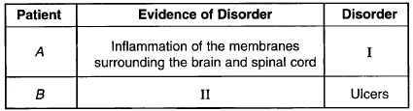
Use the diagram below and your knowledge of the living environment to answer questions 20 through 22 which follow.
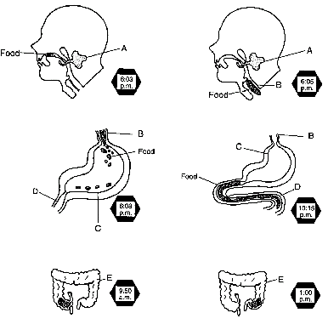
20. The diagrams illustrate the pathway and the time frame for the digestion of a hamburger consisting of ground beef, ketchup, and a whole-wheat bun. During which period does most of the digestive action of bile and pancreatic juice occur?
a. 6:03 p.m. to 6:05 p.m. | c. 10:15 p.m. to 9:50 a.m.
b. 6:05 p.m. to 6:08 p.m. | d. 9:50 a.m. to 1:00 p.m
21. The diagrams illustrate the pathway and the time frame for the digestion of a hamburger consisting of ground beef, ketchup, and a whole-wheat bun. Chemical digestion of the whole-wheat bun begins after hydrolytic enzymes are secreted by structure (a.) A (b.) B (c.) C (d.) D
22. The diagrams illustrate the pathway and the time frame for the digestion of a hamburger consisting of ground beef, ketchup, and a whole-wheat bun. An irritant can cause an erosion in the lining of structure C, leading to a disorder known as (a.) appendicitis (b.) ulcer (c.) constipation (d.) colon cancer (e.) diarrhea
23. Which foods should be included in a balanced diet as a good source of roughage? (a.) red meat and poultry (b.) fresh fruits and vegetables (c.) eggs and milk products (d.) animal fat and plant oils
24. Feces is usually about 40 percent water and 60 percent solid matter. Reducing the water content to 20 percent would most likely result in (a.) constipation (b.) diarrhea (c.) gallstones (d.) ulcers
25. Food is usually kept from entering the trachea by the (a.) anus (b.) ribs (c.) esophagus (d.) epiglottis (e.) diaphragm
Use the human digestive diagram and your knowledge of the living environment to answer questions 26 through 28.
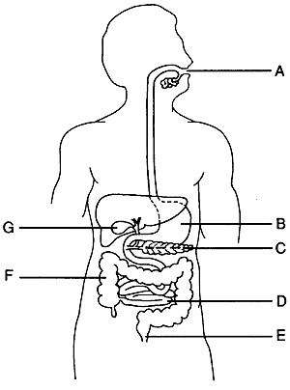
26. A painful condition resulting from the formation of small stone-like deposits o cholesterol may be treated by surgically removing structure (a.) A (b.) B (c.) C (d.) D (e.) G
27. Which letter indicates the organ that secretes hydrochloric acid and protease? (a.) A (b.) B (c.) C (d.) D (e.) E (f.) F
28. Which substance is normally absorbed by structure F? (a.) bile (b.) nutrients (c.) HCl (d.) water
29. Which food would provide the most roughage for the body? (a.) fried chicken and a milkshake (b.) baked fresh fish (c.) lettuce and tomato salad (d.) a 99 cent whopper (hamburger) special

30. The diagram shows a particle of food being moved along the human digestive tract by alternate waves of relaxation and contraction of the muscular walls of the esophagus. Which process causes the movement of the food down the esophagus? (a.) circulation (b.) active transport (c.) osmosis (d.) peristalsis | 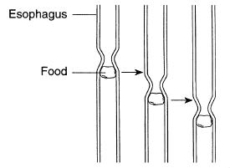
Use the diagram below and your knowledge of the living environment to answer questions 31 through 33.
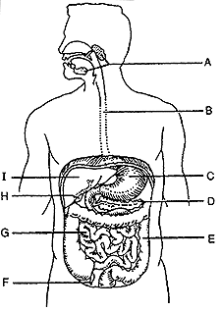
31. The end products of protein digestion diffuse into the villi that are present in the lining of structure (a.) H (b.) G (c.) F (d.) C (e.) I
32. Which organs are involved in the storage of glycogen? (a.) A and E (b.) B and F (c.) C and H (d.) D and I
33. Clinical studies have indicated that an increase in retention time of material in structure E is related to the occurrence of colon and rectal cancer. What could a person do to help decrease retention time in this structure? (a.) limit the amount of physical activity before meals (b.) increase protein consumption and decrease carbohydrate consumption (c.) consume more fruits, vegetables, and grains (d.) decrease intake of unsaturated fats and increase intake of saturated fats
Use the diagram which follows and your knowledge of the living environment to answer questions 34 through 36 which follow.
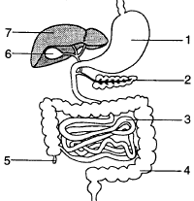
34. The diagram represents the digestive system of a student who has eaten a sandwich consisting of two slices of bread, chicken, lettuce, and mayonnaise. The final reactions for the complete hydrolysis of the bread would occur in organ (a.) 1 (b.) 2 (c.) 3 (d.) 4 (e.) 5
35. The diagram represents the digestive system of a student who has eaten a sandwich consisting of two slices of bread, chicken, lettuce, and mayonnaise. Which organ produces a substance that would be used in the emulsification of the lipids in the mayonnaise? (a.) 1 (b.) 2 (c.) 3 (d.) 4 (e.) 7
36. The diagram represents the digestive system of a student who has eaten a sandwich consisting of two slices of bread, chicken, lettuce, and mayonnaise. In which organs would chemical digestion of the chicken take place? (a.) 1 and 3 (b.) 1 and 7 (c.) 2 and 6 (d.) 3 and 5

37. Which chemical reaction is shown in the table at the right? (a.) hydrolysis of a lipid (b.) synthesis of a dipeptide (c.) hydrolysis of a disaccharide (d.) synthesis of a carbohydrate | 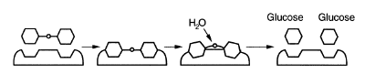

Use the diagram at the right and your knowledge of the living environment to answer questions 38 through 40.  38. From which structure are glucose and amino acids normally absorbed into the circulatory system?  39. In which structure does the initial hydrolysis of carbohydrates occur?  40. In which structure does extracellular chemical digestion of protein begin? | 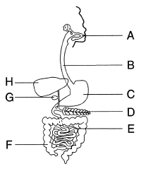
41. Which substance is a nutrient in the human diet? (a.) oxygen (b.) carbon dioxide (c.) roughage (d.) water
42. After food enters the small intestine, lipases, proteases, and amylases are secreted into the small intestine by the (a.) liver (b.) pancreas (c.) mouth (d.) large intestine
43. In some regions of the world, children suffer from a protein deficiency known as kwashiorkor. This deficiency occurs when a child's diet is changed from high-protein breast milk to watery cereal. Even though the child is receiving calories, the child becomes sick and less active, and growth ceases. These symptoms are probably due to (a.) too many nucleic acids in the diet (b.) not enough carbohydrates in the diet (c.) an overconsumption of complete protein foods (d.) a lack of essential amino acids in the diet
44. Which type of digestion occurs in the mouth when an individual chews a piece of bread? (a.) chemical digestion (b.) mechanical digestion (c.) both chemical and mechanical digestion (d.) neither chemical nor mechanical digestion
45. In humans, chemical digestion is accomplished by enzyme action that begins in the mouth and ends in the (a.) liver (b.) small intestine (c.) gall bladder (d.) stomach
Just for fun, identify the lettered structures on the human digestion diagram which follows.
Name the organism digestive organ where each of the following chiefly occurs.
Some answers may be repeated more than once.
1. This organ produces gastric juice in humans.
2. HCl is produced in this human alimentary canal organ.
3. This is where bile is temporarily stored in many humans.
4. This organ produces an emulsifying fluid.
5. This is where peristalsis begins in the human alimentary canal.
6. This is another name for the throat in the human.
7. This is another name for the food pipe.
8. Amylase begins its function in this organ in most humans.
9. Most chemical digestion and absorption occurs in this organ in humans.
10. This is the largest internal organ in the human body.
11. These structures begin the mechanical breakdown of our food.
12. This structure resorbs excess water and forms the feces.
13. This structure regulates the passage of food from the stomach to the
small intestine.
Now hopefully some correct answers!
1. b
2. c
3. c
4. e
5. d
6. b
7. b
8. b
9. c
10. b
11. c
12. a
13. e
14. d
15. e
16. d
17. b
18. c
19. b
20. c
21. a
22. b
23. b
24. a
25. d
26. e
27. b
28. d
29. c
30. d
31. b
32. d
33. c
34. c
35. e
36. a
37. c
38. e
39. a
40. c
41. d
42. b
43. d
44. b
45. b
Digestion Diagram
A -- salivary glands
B -- esophagus
C -- stomach
D -- pancreas
E -- large intestine
F -- appendix
G -- small intestine
H -- gall bladder
I -- liver
Name the organ which fits the description section.
1. stomach
2. stomach
3. gall bladder
4. liver
5. esophagus
6. pharynx
7. esophagus
8. mouth
9. small intestine
10. liver
11. teeth
12. large intestine
13. pyloric sphincter

